Chapter 8:
SPC & Production

Objectives

After completing this section, you will be able to:

- Enter Parameters and Collect Data for Statistical Analysis
- Set up and Collect Data to calculate Overall Equipment Effectiveness

Contents
SPC 249
SPC Data Collection 249
SPC Formula 251
SPC Chart 252
Data Analysis 254
SPC Data Collection Charts 254
Production 256
Production Configuration 256
Product Capacity 256
Data Collection 257

Figure of Tables

Figure 1 Asset Data Collection Screen 249
Figure 2 SPC Data Collection Screen 249
Figure 3 SPC Chart for Single SPC Sample 250
Figure 4 Grid View 250
Figure 5 Example of Run Rule Violation Pop-Up Screen 251
Figure 6 SPC Formula Data Collection 251
Figure 7 SPC Formula Data Collection Based on SPC 252
Figure 8 Data Point Screen 253
Figure 9 Data Analysis Module / SPC Charts Submodule 255
Figure 10 Product Capacity Viewer 256
Figure 11 Product Capacity Detail Screen 257
Figure 12 Production Data Collection Screen 257

SPC

SPC Data Collection
SPC uses statistical techniques to primarily measure and improve the reliability of processes and equipment uptime. As the data is collected, it detects any unusual variation in the process which could indicate a problem. By understanding performance trends, users are able to establish rules that support Predictive Maintenance strategies. SPC is collected using the Data Collection feature and can be collected against Assets, Inventory Items, Work Tracking Work Orders, WIP Work Orders, etc. See Chapter 10 Settings on how to set up the Data Collection.
To collect data, click on the Data Collection icon located on the object’s viewer or its Detail Screen toolbar. The Data Collection screen will appear.

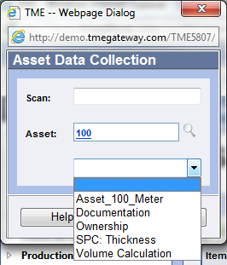
Figure 1 Asset Data Collection Screen

Choose the appropriate Collection from the drop down screen and click on . The Collection screen will open with the fields for which data is to be collected. Enter in the values. Click Submit when finished entering data.
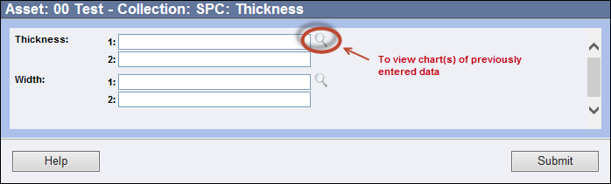
Figure 2 SPC Data Collection Screen

The chart(s) may open automatically upon submittal for all samples in the collection for which the TME Administrator set up automatic viewing. If not, and the User wants to see the chart(s), he/she needs to access the Data Collection screen again and click on the look up icon to the right of the first field for each sample.

To view the data in a grid format that can be searched, click on View Data in Grid.

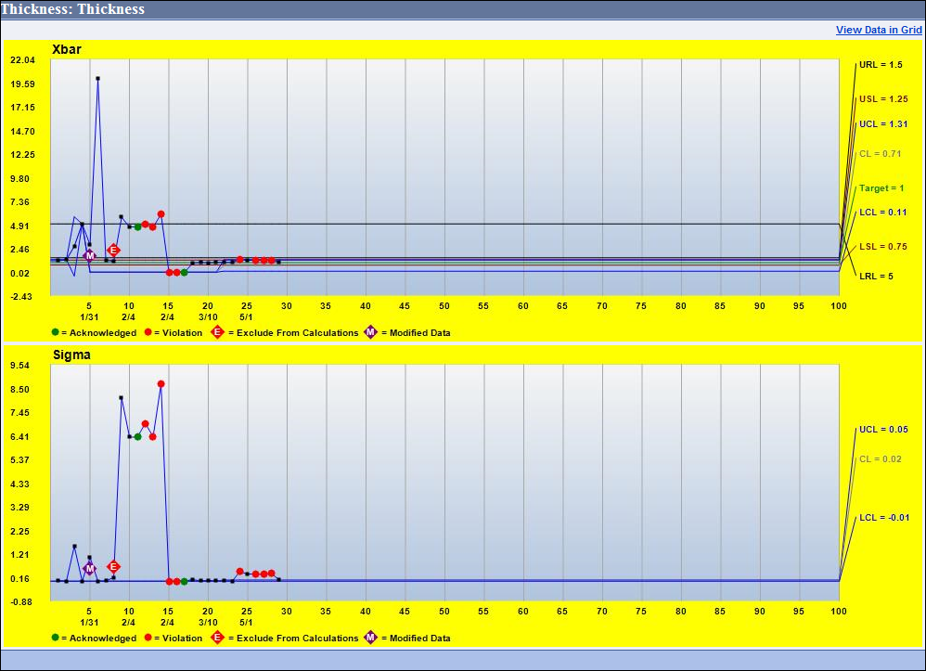
Figure 3 SPC Chart for Single SPC Sample

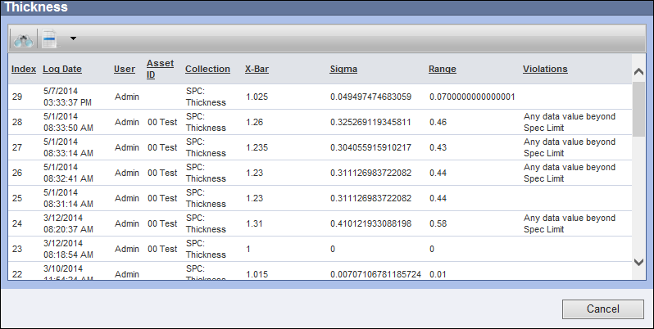
Figure 4 Grid View

If run rules have been set up, several options for notification of a violation of the rule(s) are available. A popup screen may appear or an email can be sent to designated Users. If the SPC data is collected against an Asset, there are additional options: the status of the Asset may be changed (automatically) and/or a Work Order can be generated. The User may have a popup requiring the entry of Assignable Cause, Corrective Action and Comments.

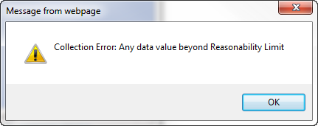
Figure 5 Example of Run Rule Violation Pop-Up Screen

SPC Formula
SPC Formula variables work similarly to regular Formula variables except that the value calculated is then charted in an SPC chart. Numerical values are entered and the SPC Formula calculates off those numbers. The values for the SPC Formulas are treated as single sample SPC entries and have targets, control limits, cpk calculations, etc.

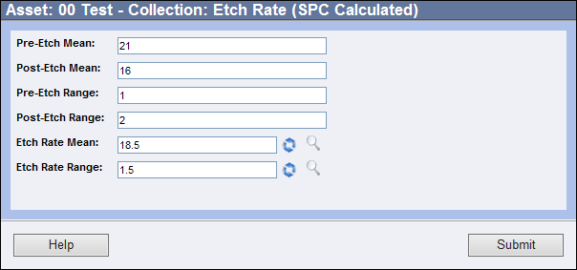
Figure 6 SPC Formula Data Collection

In addition to calculating SPC formulas off of numerical values, TME can calculate SPC formulas off the collection of other SPC variables. An example would be using an SPC Formula to chart the Xbar/R of the minimum values of several SPC variables.

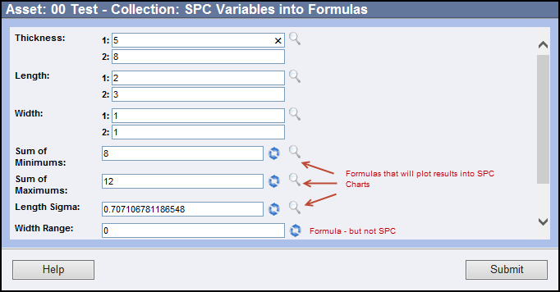
Figure 7 SPC Formula Data Collection Based on SPC

SPC Chart
To view the chart of previous entries, click on the icon to the right of the first point field. The X-Bar and R/Sigma/Only charts will appear on the History screen.
- Point Detail Screen
If a data point had triggered a violation of a run rule, the Violation tag will be set on top of the point. Once that data point has been acknowledged, the Acknowledge tag will appear in place of the Violation tag.
Click on a data point within either chart to display the Point detail screen for that point. The screen shows the Sub Group designation, control limits, X-bar, Range, Standard Deviation (Sigma), Cp and Cpk statistics, data point values reported, list of violation(s) of any run rules as well as the entry of Assignable Cause, Corrective Action and Comments as entered by the User.
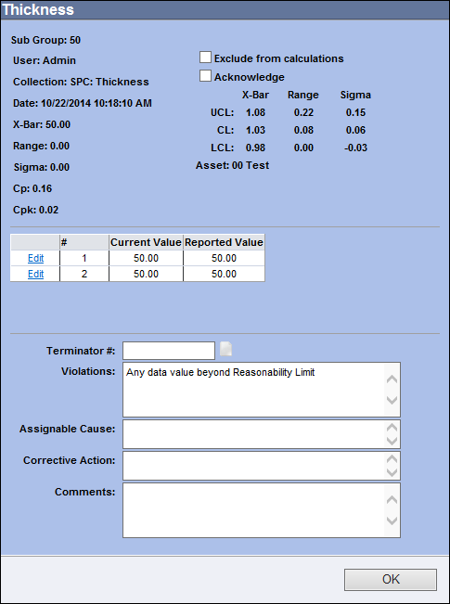
Figure 8 Data Point Screen
The data point can be excluded from calculations by selecting the checkbox "Exclude from Calculations." The Exclude from Calculations tag will display in the charts above the data point to indicate its exclusion.
If the point is in violation, it can be acknowledged by selecting the checkbox “Acknowledge”.
If a violation has been indicated, the Terminator #, Assignable Cause, Corrective Action and Comments may be typed in accordingly at this time (if not required immediately upon submitting the data). A popup screen will appear to let the Operator know what action must be taken when clicking OK and the entry is missing. If the item(s) is required, the Operator will not be able to enter the next Sample until the missing item(s) has been submitted. The operator will know that data cannot be collected for a variable then the caption is in red font on the Data Collection screen. He/she will have to click on the LookUp icon to get to the chart and then click on the point to open the detail screen and supply the missing data. Please see Appendix 7: OCAP for further details regarding Terminator #s.
Adjacent to the Terminator # field is an icon for viewing any document that has been associated to the Data Collection. This feature was designed in order to comply with OCAP standards. Please see Chapter 10 Settings: Variable Groups / Data Details for more information on how to associate a Document to the Collection and Appendix 7: OCAP for further details on OCAP standards.
To edit the data point, click the Edit link to the left of the value number that needs to be changed. Type in the new values and click Update to save the change or Cancel to cancel. Enter in a Comment. TME requires that a Comment be provided anytime a point is edited. A popup will appear stating the requirement if the Operator clicks OK and a Comment has not been submitted. The Modified Data tag will display in the charts above the data point to indicate its modification.
Click the OK button to close and save the screen. Close the chart screen and if back to the Data Collection screen, close it or enter additional samples and click Submit.

Definitions of run rule violations as well as how the SPC metrics are calculated are provided in Appendix 5: SPC Calculations.

Data Analysis

SPC Data Collection Charts

The SPC Data Collection Charts can be viewed directly from the object from which the collection was entered or via the Data Analysis Module. The Data Analysis module can be accessed via Go To from the Task Bar or within the Workspace (may need to be configured via Tools > Configure Workspace).

The charts are organized into folders/subfolders as configured by the TME Administrator and then listed by Variable Group Name / Variable Name / Caption. When opened they show the same chart as if opened from the object.

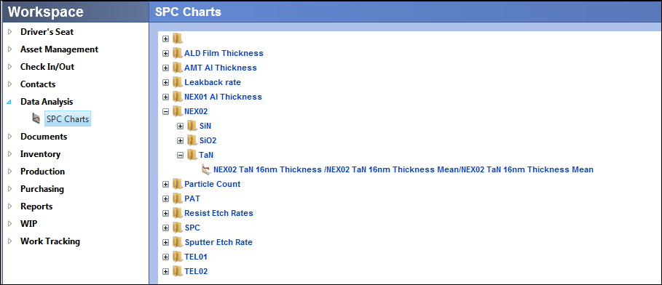
Figure 9 Data Analysis Module / SPC Charts Submodule

Production

Production Configuration
Calculating Overall Equipment Effectiveness (OEE) will help improve the performance of machinery and plant equipment. Production / OEE metrics will show how improvements in changeovers, quality and machine reliability will affect the bottom line. The Production module can be accessed via Go To from the Task Bar or the appropriate Menu Group.
It consists of two submodules, Product Capacity and Data Collection. The Product Capacity submodule is where the product capacity for different Assets is defined, i.e., an Asset can produce 100 units of a particular product per hour; whereas the Data Collection submodule is where the User enters the units produced along with defects for a specific time period. Along with the Asset status information (uptime vs. downtime), the system's runtime engine calculates OEE as well other metrics.

Product Capacity
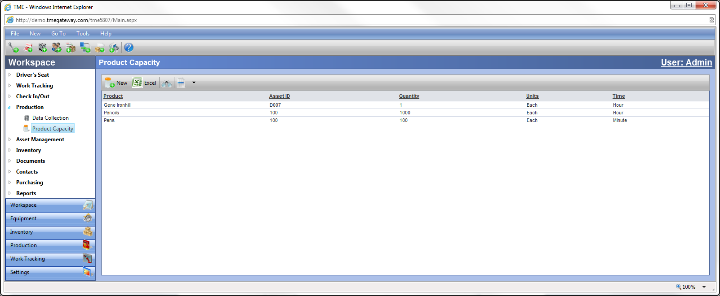
Figure 10 Product Capacity Viewer
New product capacities can be added by clicking on at the left side of the Viewer Toolbar. Type in the Product Name (required). Select the Asset which is to be tested as well as the Quantity, Units and Time for the product. Comments may be typed into the Comments field.
Multiple products can be produced by a single asset and therefore the system can have multiple capacities for a single Asset.
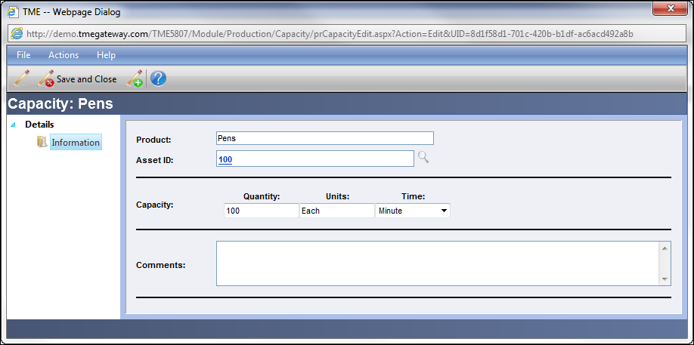
Figure 11 Product Capacity Detail Screen

Data Collection
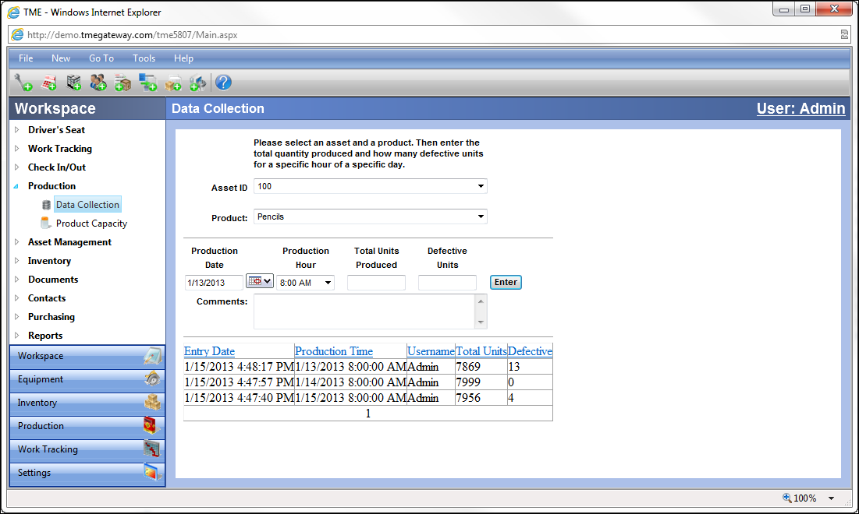
Figure 12 Production Data Collection Screen
Select the tool from the Asset ID drop-down list. Choose the appropriate product from the Product drop-down list. Click on the calendar icon to select an the Production Date and then select the Production Hour. Type in the Total Units Produced and the Defective Units for the time period. Type in Comments accordingly.
If visible, click on . The attribute fields have been predefined by the TME Administrator. Required Attributes may have default values already populated. Enter or select the Attributes accordingly.
Click on to save the data. The entries will accumulate into the viewer under the data entry area. The data can be searched and sorted in order to easily access a specific record.
The data will be compiled and the OEE and production metrics will be calculated by the TME runtime engine overnight. The metrics calculations are accessible via Reports.

For more information on how the metrics are calculated, see Appendix 6: SEMI E-10.

Exercise 1:
 Set up two Product Capacities for one of your Assets and enter a full days worth of Data using a combination of the two.

